**FIT3179 Week 9 Homework**

Name: Zhisheng Wang

Student ID: 31842992

Lab: Studio 17

Tutor:Clair Pan

**Web link**: **<https://ahahou3.github.io/FIT3179Homework/>**

**Screenshot**

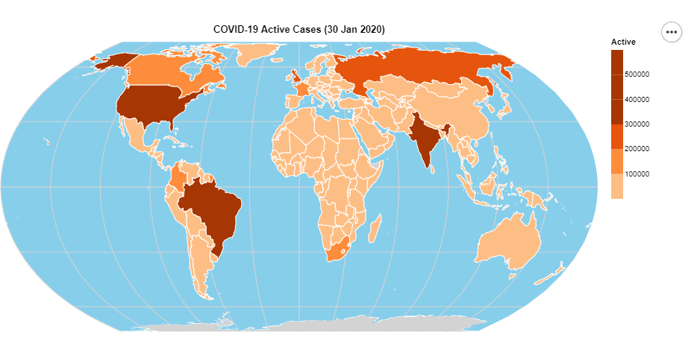

**Domain:** Worldwide Covid-19 Confirmed cases

**Author:** DEVAKUMAR K. P.

**Source**: <https://www.kaggle.com/datasets/imdevskp/corona-virus-report?resource=download>

**Data Type:** table

**Data attribute**: Area(categorical), every single cases (quantitative)

**Data transformation:**

My data pertains to active COVID-19 cases. In my dataset, there were discrepancies in some country names compared to those provided in 'ne_110m_admin_0_countries.' For the majority of cases, I adjusted my dataset to align with the provided country names. For example, in my dataset, "Congo" was divided into "Congo (Kinshasa)" and "Congo (Brazzaville)," and I modified them to "Congo" and "Dem. Rep. Congo," respectively. Additionally, for countries like Turkmenistan, where there were no active cases (0 active cases), I manually added the data.

**Reason:**

Selecting a Choropleth Map for COVID-19 data analysis is ideal because it visually communicates the spatial distribution of infection rates, enabling easy comparisons between regions or countries. This map type efficiently highlights variations in COVID-19 trends and offers customizable granularity for data representation, enhancing its effectiveness in conveying critical information.